HOTEL BOOKING WEBSITE
DB SCHEMA:
User Table
Column Name | Data Type (Example) | Description
UserId (PK) | INT | Unique ID for each user
Name | VARCHAR | User's name
Email | VARCHAR | User's email address
PasswordHash | VARCHAR | Encrypted password
MobileNumber | VARCHAR | User's phone number
Role | VARCHAR | Role (Admin / Customer)
Hotel Table
Column Name | Data Type (Example) | Description
HotelId (PK) | INT | Unique ID for each hotel
Name | VARCHAR | Hotel name
Location | VARCHAR | Hotel location
Description | TEXT | Details about hotel
ImageUrl | VARCHAR | Hotel image link
RoomType | VARCHAR | Type (Deluxe / Standard)
DeluxePrice | DECIMAL | Price for deluxe room
StandardPrice | DECIMAL | Price for standard room
DeluxeCapacity | INT | Capacity of deluxe room
StandardCapacity | INT | Capacity of standard room
DeluxeIsAvailable | BOOLEAN | Deluxe room availability
StandardIsAvailable | BOOLEAN | Standard room availability

Room Table
Column Name | Data Type (Example) | Description
RoomId (PK) | INT | Unique ID for each room
HotelId (FK) | INT | References Hotel table
RoomNumber | VARCHAR | Room number

Booking Table
Column Name | Data Type (Example) | Description
BookingId (PK) | INT | Unique booking ID
UserId (FK) | INT | References User
RoomId (FK) | INT | References Room
CheckInDate | DATE | Check-in date
CheckOutDate | DATE | Check-out date
Status | VARCHAR | Booking status (Confirmed / Cancelled)

RELATIONSHIP SCHEMA:
From Entity | To Entity | Type | Direct / Indirect | Foreign Key / Path
User | Booking | 1:N | Direct | Booking.UserId
Hotel | Room | 1:N | Direct | Room.HotelId
Room | Booking | 1:N | Direct | Booking.RoomId
Hotel | Booking | 1:N | Indirect | Hotel → Room → Booking
User | Room | M:N | Indirect | User → Booking → Room

APIS USED:
AUTH APIs
POST /api/auth/register
POST /api/auth/login
HOTEL APIs
GET /api/hotels
GET /api/hotels/{hotelId}
GET /api/search?location=&checkIn=&checkOut=
POST /api/hotels (Admin)
PUT /api/hotels/{hotelId} (Admin)
DELETE /api/hotels/{hotelId} (Admin)
ROOM APIs
GET /api/hotels/{hotelId}/rooms
DELETE /api/rooms/{roomId} (Admin)
BOOKING APIs
POST /api/bookings
GET /api/bookings/user/{userId}
PUT /api/bookings/{bookingId}/cancel
ADMIN APIs
GET /api/admin/bookings

ARCHITECTURE DIAGRAM:
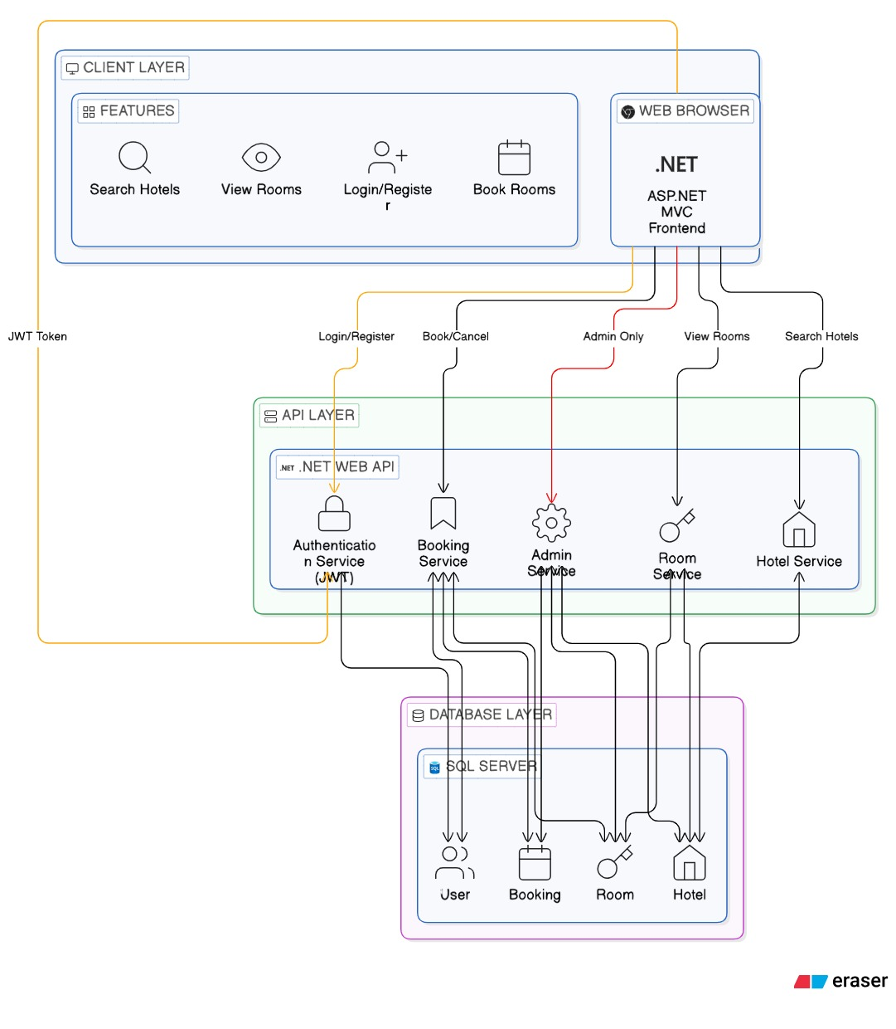

USE CASE DIAGRAM:

